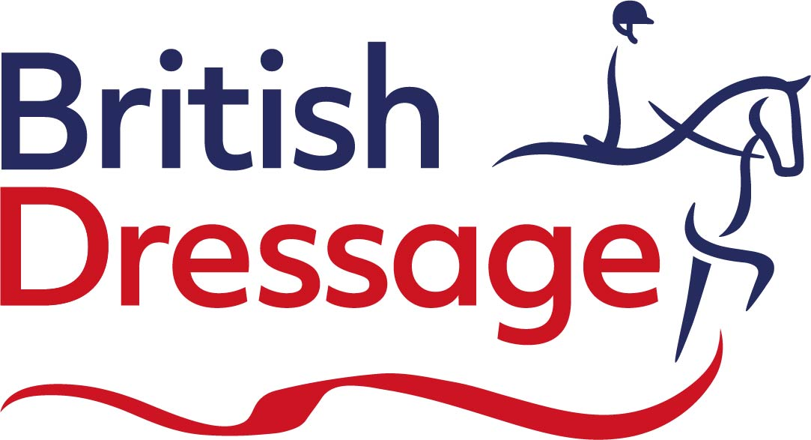
Communications Executive

We are looking for a creative and dynamic Communications Executive to join our Marketing and Communications team. This is an exciting opportunity for a talented communicator to play a key role in shaping and delivering engaging content across a wide range of channels. Working closely with the Head of Marketing and Communications, you will help bring our organisation’s activities to life through compelling storytelling and written content.

In this role, you will be responsible for producing high-quality written communications for our website, newsletters and stakeholder updates, ensuring all content aligns with our wider strategy.
You will work with the rest of the Marketing and Communications Team to support day-to-day content delivery, keeping audiences informed on key updates, events, and initiatives, while also contributing to the development of creative campaigns across social media and digital platforms. From crafting engaging articles to supporting video content, you will play a central role in strengthening our voice and increasing the visibility of British Dressage.

You will also act as a key point of contact for media relations, handling press enquiries, writing press releases, and proactively generating positive publicity opportunities. This includes identifying compelling stories, developing case studies and building strong relationships with media contacts, photographers, and stakeholders. In addition, you will support communications at major events, ensuring consistent and engaging coverage across all channels.

The ideal candidate will have proven experience in a communications role, with exceptional copywriting, editing and proofreading skills. You will be confident in creating content for digital and print platforms, highly organized, and able to manage multiple priorities working to tight deadlines.

We are looking for an individual who has a proactive mindset, strong interpersonal skills, and the ability to work equally effectively independently and collaboratively. A passion for equestrianism and sport generally, is essential. Experience with design tools such as Canva or Adobe would also be advantageous.

If you are a motivated and enthusiastic communicator with a flair for storytelling and a keen eye for detail, we would love to hear from you. This is a fantastic opportunity to contribute to a fast-paced and supportive team, where your ideas and creativity will make a real impact.

Due to the nature of our sport a flexible approach to working, including some weekends and evenings, will be required. You must also have a full, clean driving license and be prepared to travel as necessary. This is a hybrid role, with three days in the office in Meriden, two days working from home. For more information, including a full job description, please visit www.britishdressage.co.uk.

To apply for this role, please send a copy of your CV and a covering letter outlining your suitability by email to: jobs@britishdressage.co.uk.

Salary: c. £30,000-£32,000, subject to experience
Closing date for applications: Wednesday 8 July 2026

